**Voltage Stability Indexes**

**Requirements:**

* Previously developed index requires three simulations at slightly different operating conditions, to give a good estimate of the voltage index.
* But the simulation can only run one time continuously.

**Proposed Method:**

* Post-contingency index values:
* The new method runs the simulation for a longer time, and the “load increment” will be sequentially in a given pattern (e.g. add 5 MW every 5 seconds).
* This must be done in the load closest to the "pilot" bus or buses (chosen for monitoring the index).
* Depending on how many of these "load increments" are allowed (either by you, or by the system response), you can get better and better accuracy, the more "load increments", the better the estimate.
* Ideally, you should simulate until the load increments create a collapse, then we will give a PV curve and index estimates that are certainly "more accurate" than one with less of these changes.
* A minimum of 3 load increments is required.
* Pre-contingency index values:
* Because there is very limited information about the pre-contingency, we would need to use the voltage limits set at each bus, and the MVA limits set at the chosen lines for monitoring to give a range of most likely solutions.
* We will therefore, for the pre-contingency, have two rows instead of 1 as documented previously in the deliverable.

**Voltage stability Index-Theory:**

SBI

ABI

GBI

The three layers of the index are

* Single Bus Index (SBI)
* All Bus Index (ABI)
* Global Bus Index (GBI)

The SBI is a (NbX6) matrix, which provides the distance in pre and post contingency for each loading level to the Power (*Plim*) and voltage (*Vlim*) limits of the selected bus or group of buses. ‘Nb’ is the number of selected buses. Column 1-3 correspond to the distance for each loading level to the limit with respect to power while column 4-6 corresponds to the distance for each loading level to the limit with respect to the voltage. First row refers to the pre-contingency data while second row refers to post-contingency data. If an element of SBI is negative, then the power or voltage of some loading level has exceeded the operational limits.

The ABI is a (1X6) vector that provides the minimum distance among the each loading level to the power and voltage limits, in pre and post contingency.

The GBI is a 2-element vector that provides the overall minimum distance to the power and voltage limits.

Even though the calculation of indexes is in the same way as previously, unlike previously this code gives two sets of indexes. One set of indexes is calculated with respect to Pre-contingency PV curve-1 and second set of indexes is calculated with respect to Pre-contingency PV curve-2.

The final outputs of the voltage index calculation are the following,

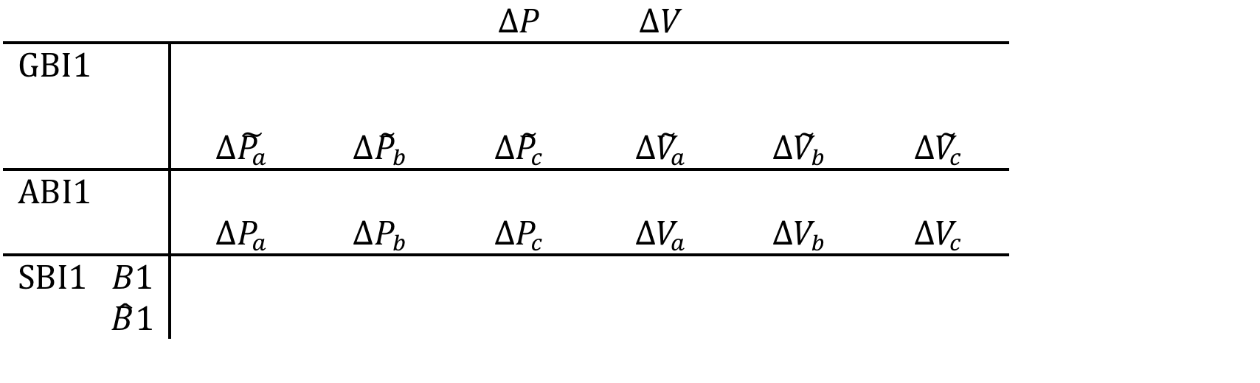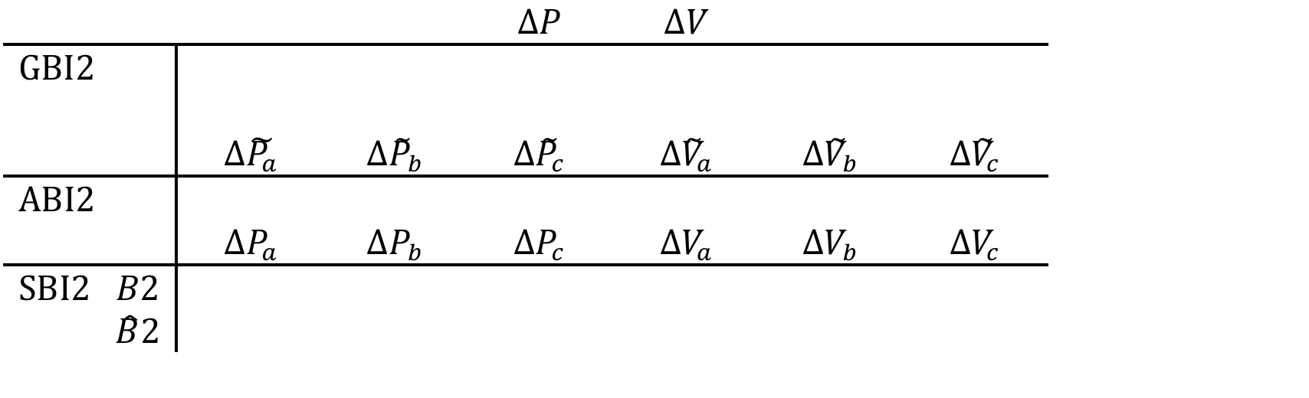

**Simulation Results:**

The main execution file for voltage stability indexes is ‘Voltage_Stability_index_testing’.

The execution of this file is explained below with ‘2bus-system’ data file. The following input variables are declared as global variables in order to be used in different Matlab functions.

‘simTime’ - Simulation time of the given data

‘faultime’ - Fault occurrence time in the given data

‘deltime ‘ - Load variation interval in the given data

‘Lb’ - Load bus that is analyzed

The variable ‘flag’ when assigned with different number (1/2/3) executes different input file. Here we want to execute 2-bus test system so, set flag to ‘1’. When the variable ‘flag’ is set to 1 then the file ‘2bus-system’ is loaded and corresponding variables (‘simTime’, ‘faultime’, ‘deltime’, ‘Lb’) are assigned to values. The network considered is shown in Figure-1.

Figure-1

The variables loaded from the file are assigned to ‘t’, ‘P’, ‘Q’ and ‘V’ respectively. The voltage and power variation of the selected load bus are plotted for reference. The following graphs for voltage and active power are obtained when ‘2bus-system’ file is loaded. It should be noted that a minimum of three load variations is required for better estimation of the PV curve.

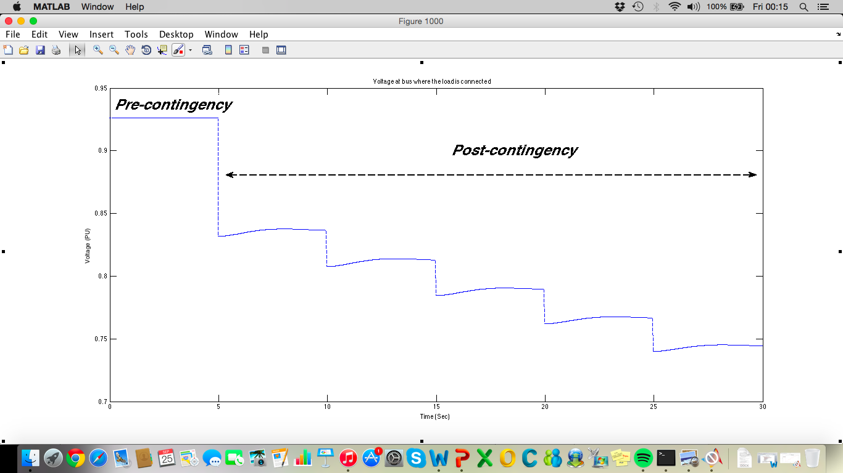

Figure-2: Voltage plot of the load bus

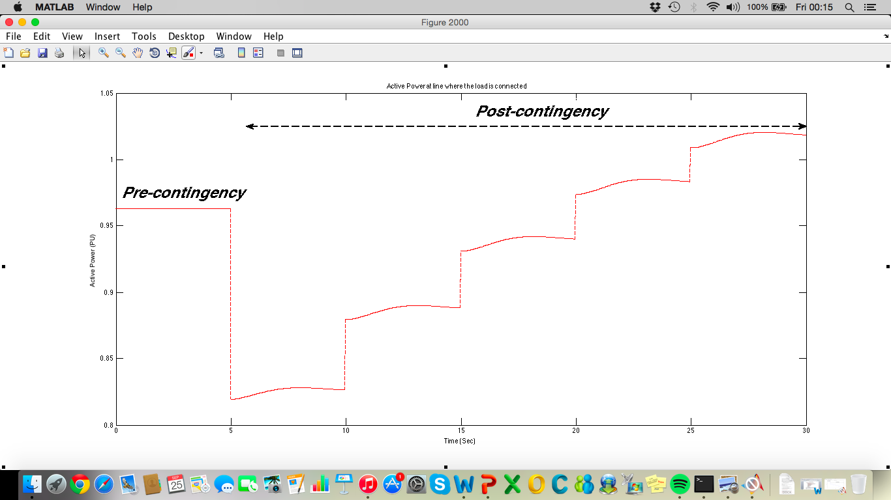

Figure-3: Active power plot of the load bus

It can be observed from the plots that contingency is created (outage of one line) at 5th sec and load variations are created after every 5 seconds from 10th second to until the end of the simulation. The ‘dynamic_voltagestability_postcontingency’ Matlab function is called to estimate the PV-curve in the post contingency state. Using them the PV curve of the post-contingency state of the given system is plotted as shown in Figure-4.

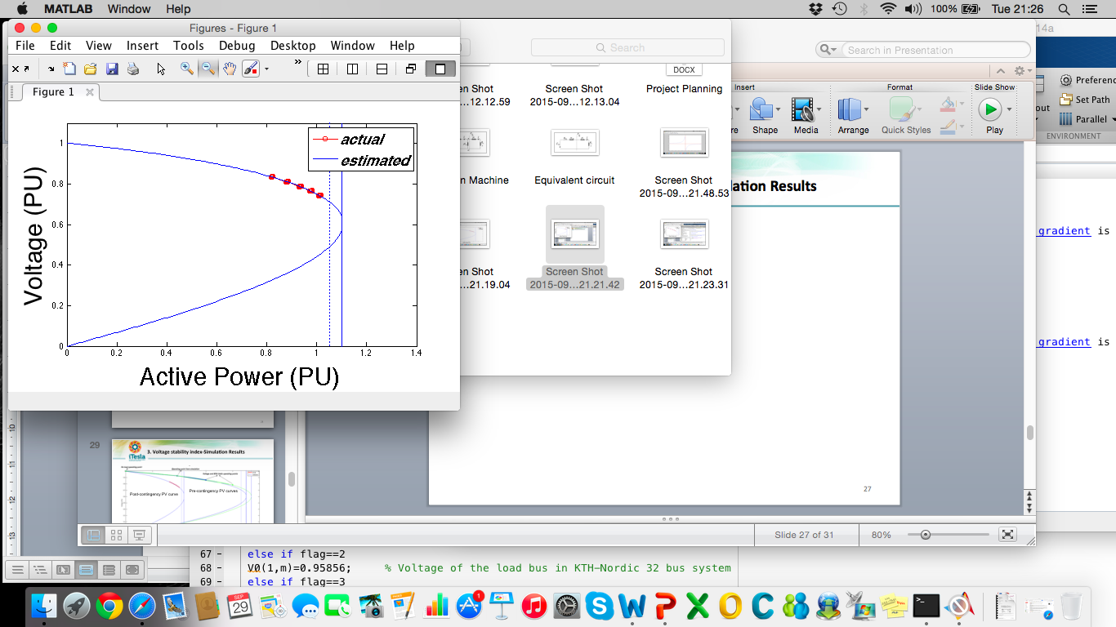

Figure-4: Post contingency PV curve

The blue line indicates the saddle node bifurcation and the dotted blue line indicates the allowable limit. It should be noted that, minimum of three operating points are required in a state (pre/post contingency) to get a better estimate of the PV curve. But in the pre-contingency state we have only one operating point (P2, V2). Because there is very limited information about the pre-contingency state, we need to use the voltage limits set at each bus, and the MVA limits set at the chosen lines for monitoring to give a range of most likely solutions. The other two operating points are to be given by the user. The first operating point in the pre-contingency state is no load operating point. The corresponding values of ‘P1’ and ‘V1’ are entered. The second operating point in the pre-contingency state is the maximum allowed active loading of the line [Pmax1 Pmax2] and their corresponding voltages [Vmin1 Vmin2]. Thus, pre-contingency PV curves are estimated for [(P1 V1), (P2 V2), (Pmax1 Vmin1)]—Pre-contingency PV curve-1, [(P1 V1), (P2 V2), (Pmax2 Vmin2)]—Pre-contingency PV curve-2.

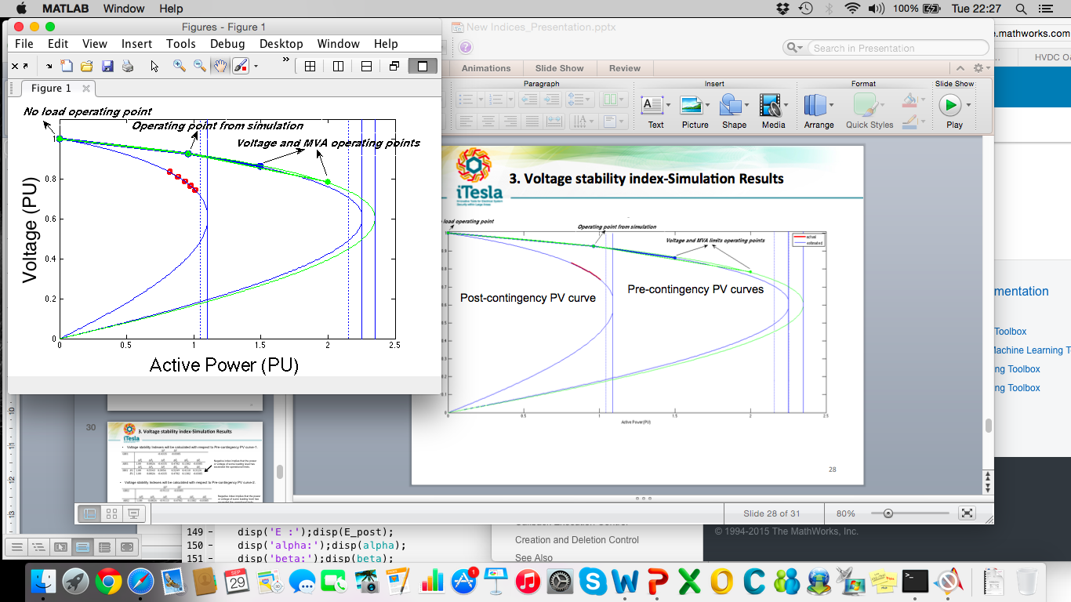

Figure-5: Pre contingency PV curves

Using these operation points in pre-contingency state, ‘XTh‘, ‘ and ‘E’ are estimated and corresponding PV curves are plotted as shown in Figure-5. Thus, it gives us the estimate that the original PV curve is in between these two pre-contingency PV curves.

The output will be displayed as shown below.

Considering the first pre-contingency PV curve (Lower limit of maximum loading)

SBI1 =

1.0000 0.5543 0.3056 0.5249 0.4110 0.3124

1.0000 0.0826 -0.4335 0.4782 0.1382 -0.0385

ABI1 =

1.0000 0.0826 -0.4335 0.4782 0.1382 -0.0385

GBI1 =

-0.4335 -0.0385

Considering the second pre-contingency PV curve (Upper limit of maximum loading)

SBI2 =

1.0000 0.5733 0.1135 0.5707 0.4533 0.2302

1.0000 0.0826 -0.9113 0.4782 0.1382 -0.0385

ABI2 =

1.0000 0.0826 -0.9113 0.4782 0.1382 -0.0385

GBI2 =

-0.9113 -0.0385

From the above output it can be observed that the third operating condition in pre-contingency state of the two curves is an unstable operating condition in post-contingency state. If an element in index is negative, then the power or voltage of some loading level has exceeded the operational limits. This can also be observed in the below figures.

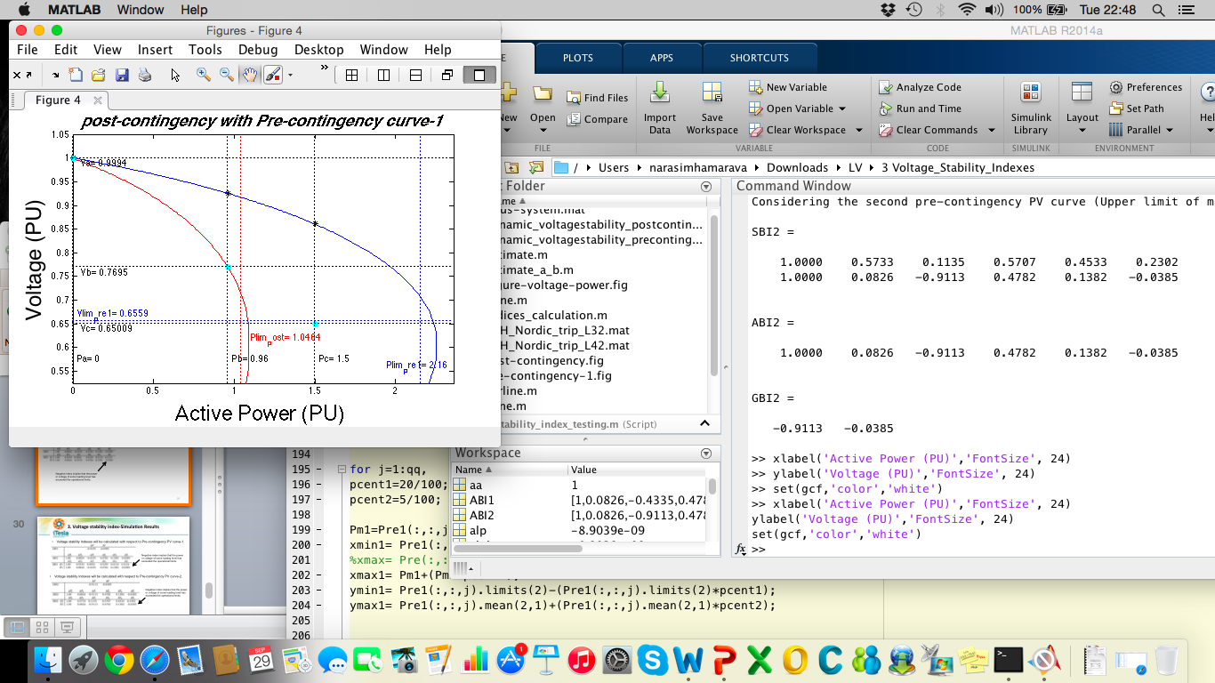

Figure-6: Post contingency PV curve with Pre-contingency PV curve-1

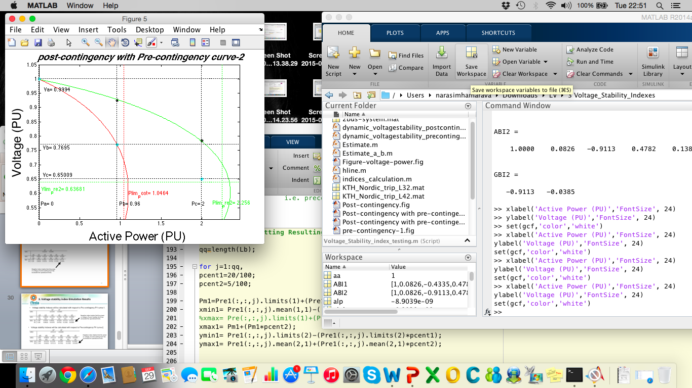

Figure-7: Post contingency PV curve with Pre-contingency PV curve-1

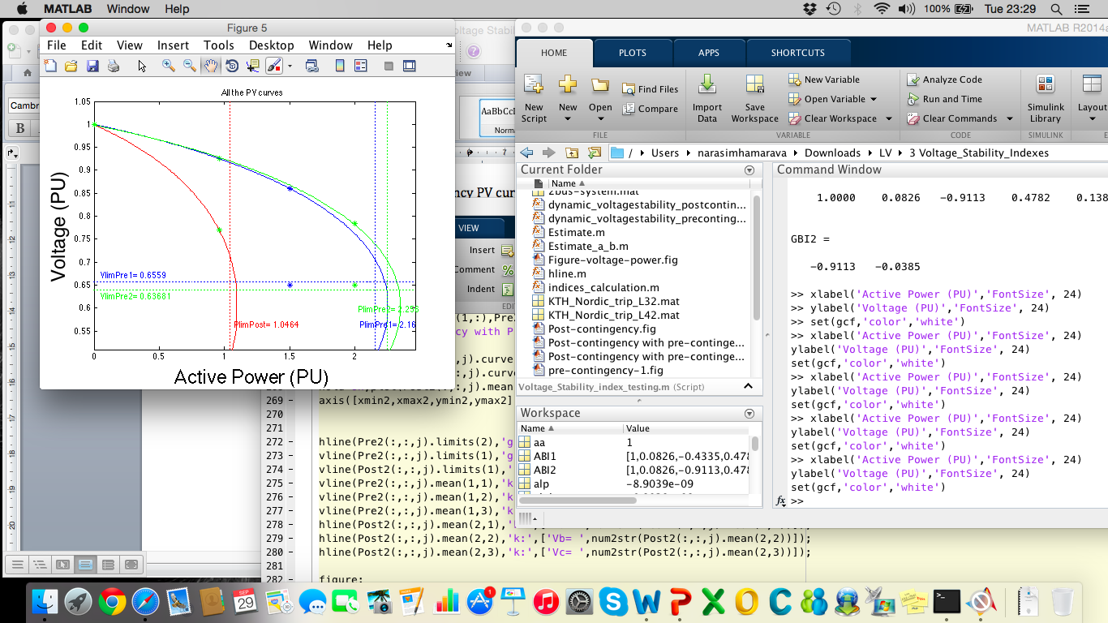

Figure-8: Post-contingency PV curve w.r.t Pre-contingency PV curves

Note:

The code can be executed with different data files by replacing the file name in any one ‘flag’ condition. Make sure that corresponding variables are updated.

‘simTime’ - Total simulation time of the data file used

‘faultime’ - Fault occurring time in the data file used

‘deltime’ - Load variation interval

‘Lb’ – Load bus to be analyzed

‘samples’ – Size of the sample interval from the data